1. Format all cells -> Autofit column width
2. Set DATE column as long date format
3. Set BASE_COST as currency format (USD)
4. No duplicate records found
5. Unnecessary whitespaces present

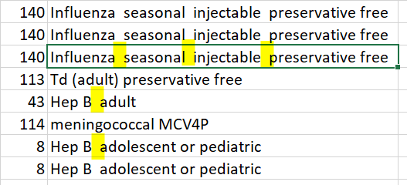

Use TRIM() function to remove unwanted/extra spaces

